**Consumer Goods Project Analysis**

Name*:* Bandi Manoja

Role*:* Data Analyst

ToolsUsed*:* MySQL, Excel

**Problem Statement**

AtliQ Hardwares (imaginary company) is one of the leading computer hardware producers in India and has expanded well in other countries, too. However, the management noticed that they do not get enough insights to make quick and smart data-informed decisions.

**REQUESTS FROM CLENTS**:

1. Provide the markets in which the customer "Atliq Exclusive" operates its business in the APAC region.

**Query:**

SELECT

DISTINCT market

FROM

dim_customer

WHERE customer LIKE "%Atliq Exclusive%"

AND region = "APAC"

Order by Market ;

**Result:**

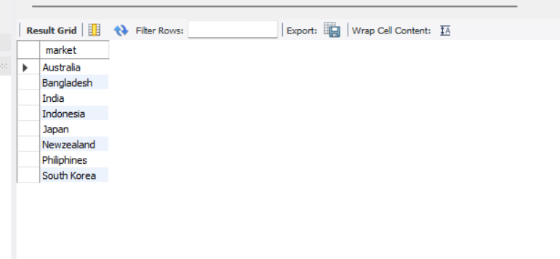

2. What is the percentage of unique products increased in 2021 vs. 2020? The final output contains these fields,

unique_products_2020

unique_products_2021

percentage_chg

**Query:**

WITH CTE_2020 AS

(

SELECT

count(Distinct p.product_code) AS unique_products_2020

FROM dim_product p

JOIN fact_sales_monthly s

ON s.product_code = p.product_code

WHERE s.fiscal_year = 2020

),

CTE_2021 AS

(

SELECT

count(Distinct p.product_code) AS unique_products_2021

FROM dim_product p

JOIN fact_sales_monthly s

ON s.product_code = p.product_code

WHERE s.fiscal_year = 2021

)

SELECT

c2020.unique_products_2020,

c2021.unique_products_2021,

ROUND(

(c2021.unique_products_2021 - c2020.unique_products_2020) * 100.0 / c2020.unique_products_2020, 2

) AS percentage_chg

FROM CTE_2020 c2020

CROSS JOIN CTE_2021 c2021;

**Result:**

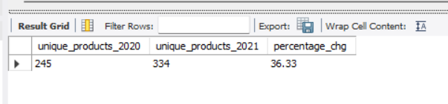

3. Provide a report with all the unique product counts for each segment and sort them in descending order of product counts. The final output contains 2 fields,

segment

product_count

**Query:**

WITH CTE AS(

SELECT

segment,

count(distinct(product_code)) AS product_count

from dim_product

GROUP BY segment

ORDER BY product_count DESC

)

SELECT *,

ROUND(product_count * 100.0 / SUM(product_count) OVER(), 2) AS segment_product_share

FROM CTE

**Result:**

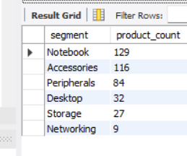

4. Follow-up: Which segment had the most increase in unique products in

2021 vs 2020? The final output contains these fields,

segment

product_count_2020

product_count_2021

difference

**Query:**

WITH CTE_2020 AS

(

SELECT p.segment,

count(DISTINCT p.product_code) AS unique_products_2020

FROM dim_product p

JOIN fact_sales_monthly s

ON s.product_code = p.product_code

WHERE s.fiscal_year = 2020

GROUP BY p.segment

),

CTE_2021 AS

(

SELECT p.segment,

count(DISTINCT p.product_code) AS unique_products_2021

FROM dim_product p

JOIN fact_sales_monthly s

ON s.product_code = p.product_code

WHERE s.fiscal_year = 2021

GROUP BY p.segment

)

SELECT

c2020.segment,

c2020.unique_products_2020,

c2021.unique_products_2021,

(c2021.unique_products_2021 - c2020.unique_products_2020) as difference

FROM CTE_2020 c2020

JOIN CTE_2021 c2021

ON c2020.segment = c2021.segment;

**Result:**

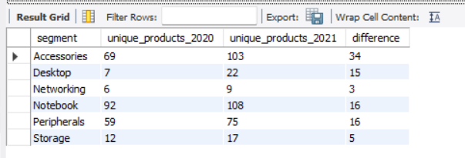

5. Get the products that have the highest and lowest manufacturing costs.

The final output should contain these fields,

product_code

product

manufacturing_cost

**Query:**

SELECT

p.product_code,

p.product,

ROUND( m.manufacturing_cost,2) as manufacturing_cost

FROM

dim_product p JOIN fact_manufacturing_cost m

on p.product_code = m.product_code

order by manufacturing_cost ;

**Result:**

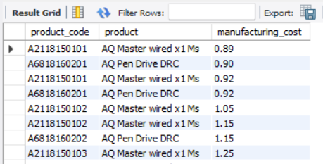

6.Generate a report which contains the top 5 customers who received anaverage high pre_invoice_discount_pct for the fiscal year 2021 and in the Indian market. The final output contains these fields,

customer_code

customer

average_discount_percentage

**Query:**

SELECT

c.customer_code,

c.customer,

ROUND(AVG(pre.pre_invoice_discount_pct),4) as avg_pre_invoice_discount_pct

FROM dim_customer c

JOIN fact_pre_invoice_deductions pre

ON c.customer_code = pre.customer_code

WHERE c.market ="INdia" AND pre.fiscal_year = 2021

GROUP BY c.customer_code,c.customer

order by avg_pre_invoice_discount_pct DESC

LIMIT 5;

**Result:**

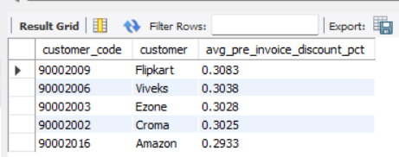

7. Get the complete report of the Gross sales amount for the customer “Atliq Exclusive” for each month. This analysis helps to get an idea of low and

high-performing months and take strategic decisions.

The final report contains these columns:

Month

Year

Gross sales Amount

**Query:**

SELECT

CONCAT(MONTHNAME(s.date), ' (', YEAR(s.date), ')') AS Month,

s.fiscal_year,

sum(g.gross_price) AS Gross_sales_Amount

FROM fact_gross_price g

JOIN fact_sales_monthly s

ON s.product_code = g.product_code

JOIN dim_customer c

ON s.customer_code = c.customer_code

WHERE c.customer = "Atliq Exclusive"

GROUP BY CONCAT(MONTHNAME(s.date), ' (', YEAR(s.date), ')') ,s.fiscal_year;

**Result:**

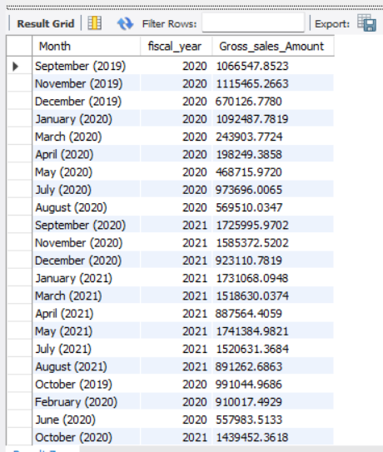

8. In which quarter of 2020, got the maximum total_sold_quantity? The final output contains these fields sorted by the

total_sold_quantity,

Quarter

total_sold_quantity

**Query:**

SELECT

CASE

WHEN MONTH(date) BETWEEN 9 AND 11 THEN 'Q1'

WHEN MONTH(date) IN (12, 1, 2) THEN 'Q2'

WHEN MONTH(date) BETWEEN 3 AND 5 THEN 'Q3'

ELSE 'Q4'

END AS Quarter,

sum(sold_quantity) AS total_sold_quantity

FROM fact_sales_monthly

WHERE fiscal_year = 2020

group by Quarter

ORDER BY total_sold_quantity DESC ;

**Result:**

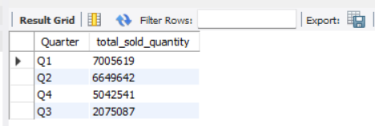

9. Which channel helped to bring more gross sales in the fiscal year 2021 and the percentage of contribution? The final output contains these fields,

channel

gross_sales_mln

percentage

**Query:**

WITH CTE AS(

SELECT

c.channel,

CONCAT(ROUND(sum(g.gross_price * s.sold_quantity)/1000000,2) , ' M') as gross_sales_mln

FROM dim_customer c

JOIN fact_sales_monthly s

on c.customer_code = s.customer_code

join fact_gross_price g

on g.product_code = s.product_code

WHERE s.fiscal_year = 2021

GROUP BY Channel

)

SELECT *,

CONCAT(

ROUND(gross_sales_mln * 100.0 / SUM(gross_sales_mln) OVER(), 2),

' %'

) AS percentage

FROM CTE

ORDER BY percentage DESC;

**Result:**

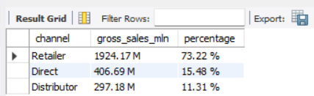

10. Get the Top 3 products in each division that have a high total_sold_quantity in the fiscal year 2021? The final output contains these

fields,

division

product_code

product

total_sold_quantity

rank_order

**Query:**

WITH CTE AS (

SELECT

p.division,

p.product_code,

p.product,

SUM(s.sold_quantity) AS total_sold_quantity,

DENSE_RANK() OVER(

PARTITION BY p.division

ORDER BY SUM(s.sold_quantity) DESC

) AS sales_rank

FROM dim_product p

JOIN fact_sales_monthly s

ON s.product_code = p.product_code

WHERE s.fiscal_year = 2021

GROUP BY

p.division,

p.product_code,

p.product

)

SELECT * from CTE WHERE sales_rank <=3;

**Result:**

